Bước 1. Tạo dự án
Bước 2. Tạo kết nối firebase

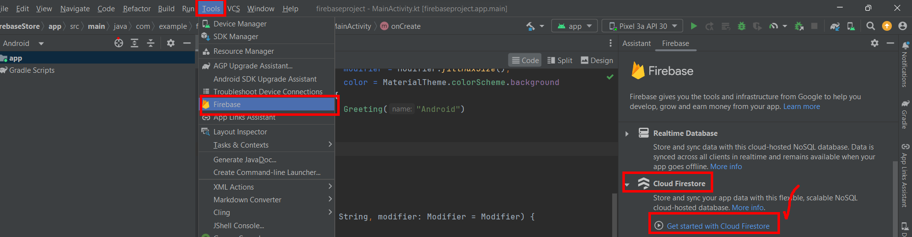

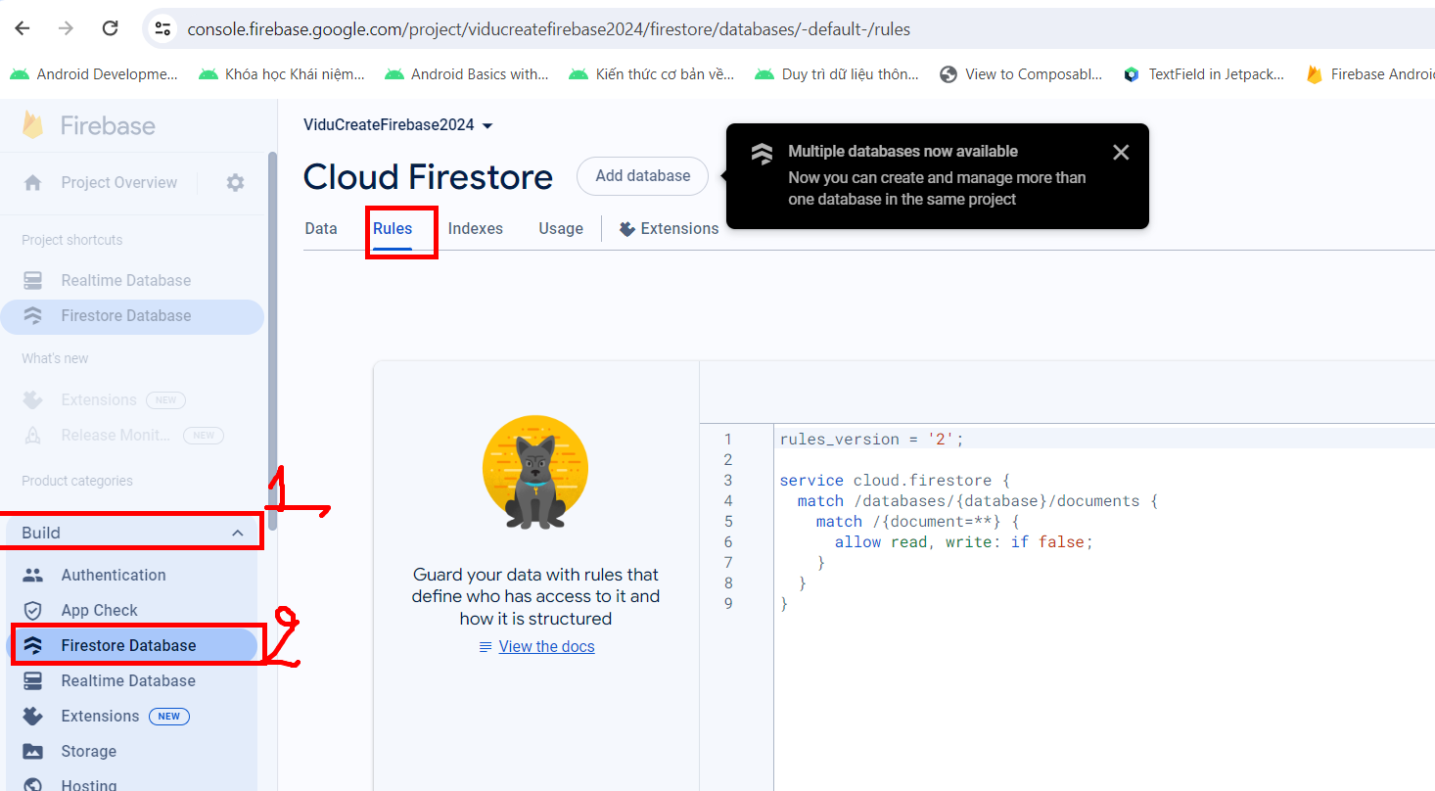
Sửa Rules cho phép read, write chọn Publish
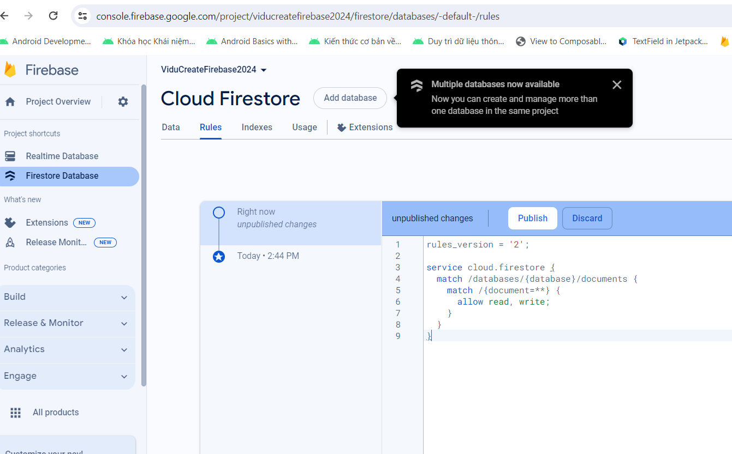

Dữ liệu chưa thêm vào
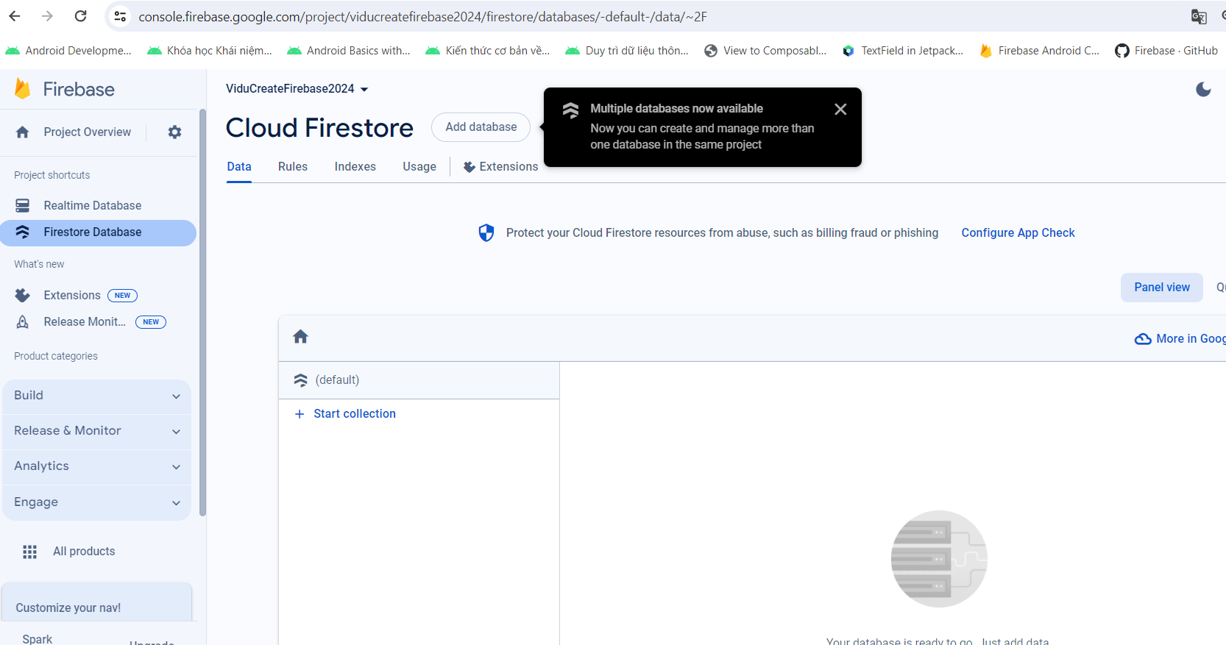

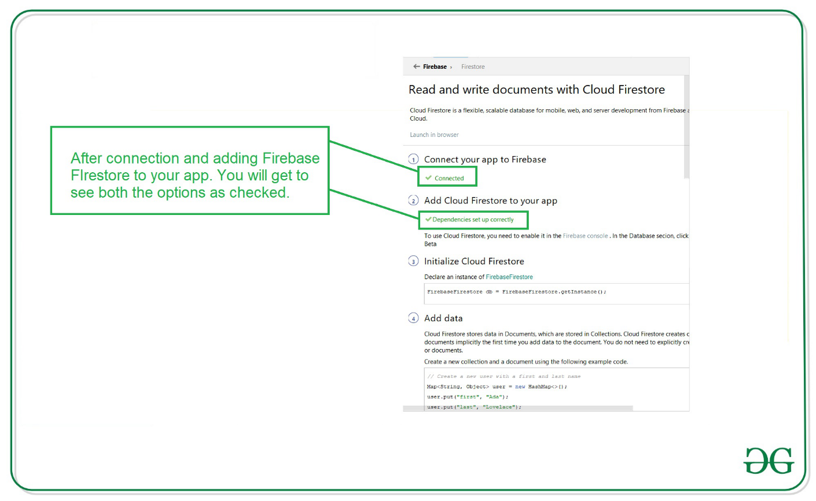

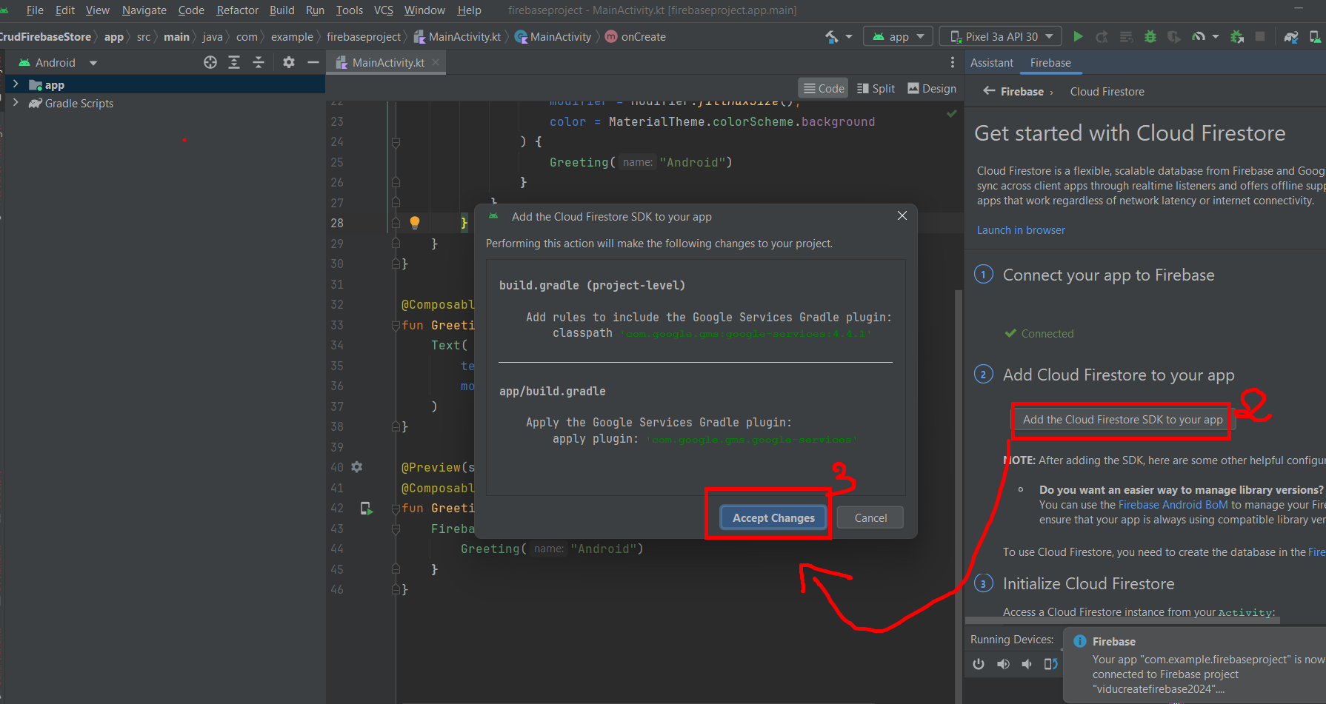

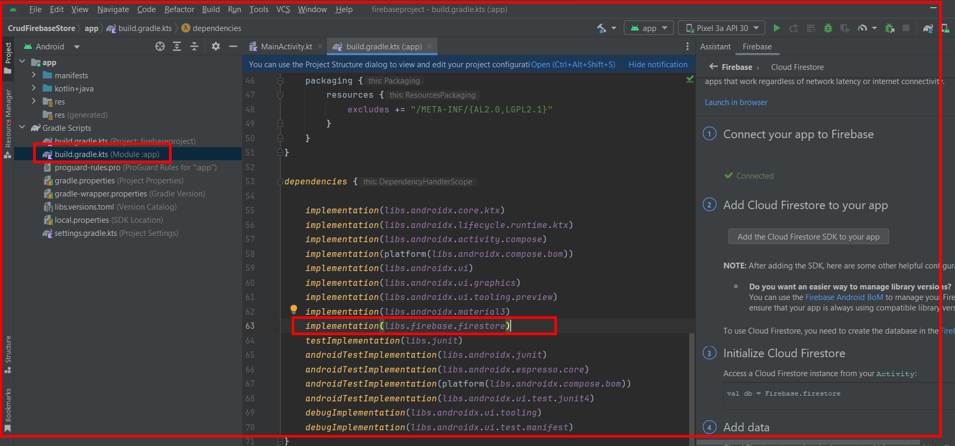

Bước 3: bổ sung truy cập dữ liệu AndroidManifest.xml file
For adding data to Firebase we should have to give permissions for accessing the internet. for adding these permissions. navigate to app>AndroidManifest.xml. Inside that file add the below permissions to it.
- XML
<!--Permissions for internet-->
<uses-permission android:name="android.permission.INTERNET" />
<uses-permission android:name="android.permission.ACCESS_NETWORK_STATE" />
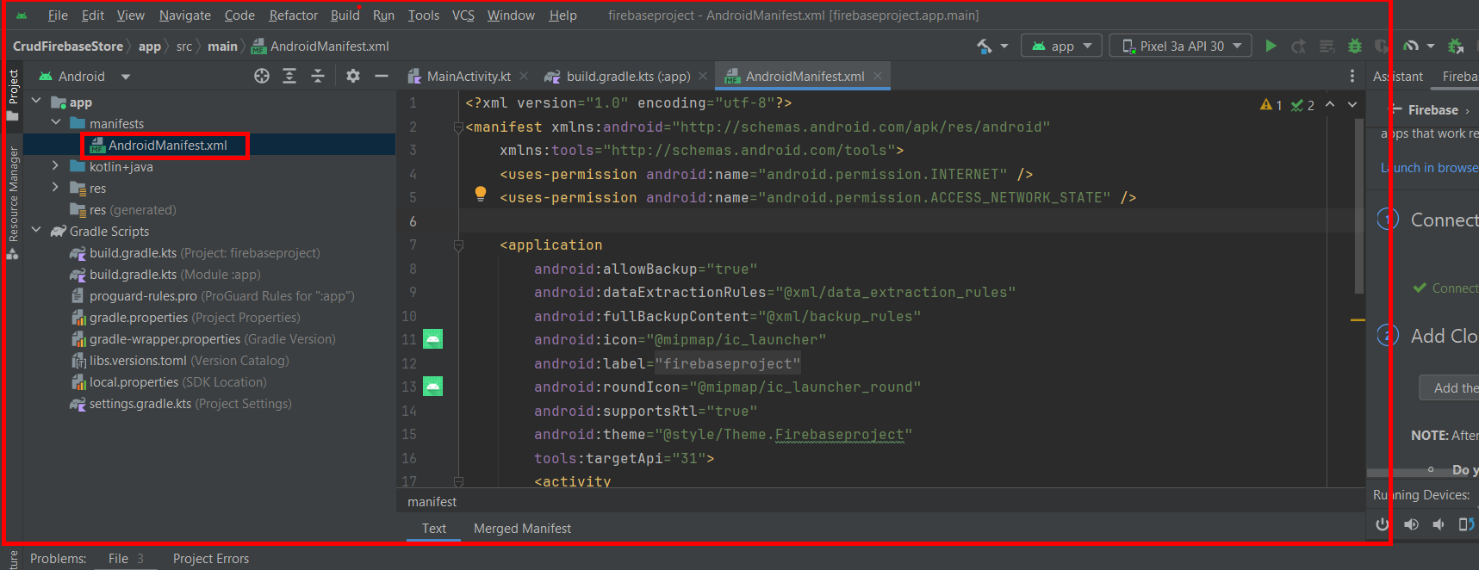

Chú ý thư viện tệp build.gradle.kts như sau

dependencies {
implementation(libs.androidx.core.ktx)
implementation(libs.androidx.lifecycle.runtime.ktx)
implementation(libs.androidx.activity.compose)
implementation(platform(libs.androidx.compose.bom))
implementation(libs.androidx.ui)
implementation(libs.androidx.ui.graphics)
implementation(libs.androidx.ui.tooling.preview)
implementation(libs.androidx.material3)
implementation("androidx.compose.material3:material3:1.0.1")
implementation("androidx.compose.material:material:1.3.1")
implementation("androidx.compose.material3:material3-window-size-class:1.0.1")
implementation(platform("com.google.firebase:firebase-bom:32.8.1"))
implementation(libs.firebase.firestore)
testImplementation(libs.junit)
androidTestImplementation(libs.androidx.junit)
androidTestImplementation(libs.androidx.espresso.core)
androidTestImplementation(platform(libs.androidx.compose.bom))
androidTestImplementation(libs.androidx.ui.test.junit4)
debugImplementation(libs.androidx.ui.tooling)
debugImplementation(libs.androidx.ui.test.manifest)
}

Bước 4: Tạo Model: Course

Navigate to app>java>your app’s package name>Right click on it>New Kotlin class/file and name it as Course and add the below code to it. Comments are added to it to get to know it in detail.
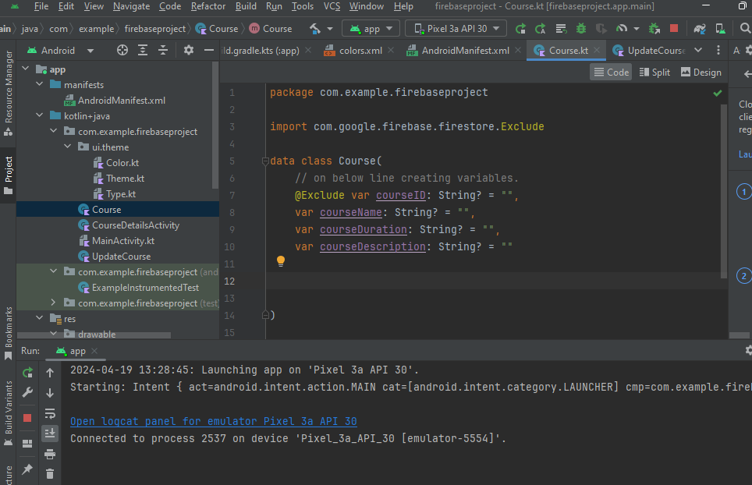

import com.google.firebase.firestore.Exclude
data class Course(
// on below line creating variables.
@Exclude var courseID: String? = "",
var courseName: String? = "",
var courseDuration: String? = "",
var courseDescription: String? = ""
)

Bước 5. Code file MainActivity.kt theo gợi ý

package com.example.firebaseproject
import android.os.Bundle
import androidx.activity.ComponentActivity
import androidx.activity.compose.setContent
import androidx.compose.material3.Text
import androidx.compose.material3.Button
import androidx.compose.runtime.Composable
import androidx.compose.ui.Modifier
import android.annotation.SuppressLint
import android.content.Context
import android.content.Intent
import android.text.TextUtils
import android.widget.Toast
import androidx.compose.foundation.background
import androidx.compose.foundation.layout.*
import androidx.compose.material.TopAppBar
import androidx.compose.material3.MaterialTheme
import androidx.compose.material3.Scaffold
import androidx.compose.material3.Surface
import androidx.compose.material3.TextField
import androidx.compose.runtime.mutableStateOf
import androidx.compose.runtime.remember
import androidx.compose.ui.Alignment
import androidx.compose.ui.graphics.Color
import androidx.compose.ui.text.TextStyle
import androidx.compose.ui.unit.dp
import androidx.compose.ui.unit.sp
import androidx.compose.ui.platform.LocalContext
import androidx.compose.ui.text.style.TextAlign
import com.example.firebaseproject.ui.theme.FirebaseprojectTheme
import com.example.firebaseproject.ui.theme.greenColor
import com.google.firebase.firestore.CollectionReference
import com.google.firebase.firestore.FirebaseFirestore
class MainActivity : ComponentActivity() {
@SuppressLint("UnrememberedMutableState")
override fun onCreate(savedInstanceState: Bundle?) {
super.onCreate(savedInstanceState)
setContent {
FirebaseprojectTheme {
// A surface container using the 'background' color from the theme
Surface(
modifier = Modifier.fillMaxSize(),
color = MaterialTheme.colorScheme.background
) {
Scaffold(
// in scaffold we are specifying the top bar.
topBar = {
// inside top bar we are specifying
// background color.
TopAppBar(backgroundColor = greenColor,
// along with that we are specifying
// title for our top bar.
title = {
// in the top bar we are
// specifying tile as a text
Text(
// on below line we are specifying
// text to display in top app bar
text = "GFG",
// on below line we are specifying
// modifier to fill max width
modifier = Modifier.fillMaxWidth(),
// on below line we are
// specifying text alignment
textAlign = TextAlign.Center,
// on below line we are specifying
// color for our text.
color = Color.White
)
})
}) {innerPadding ->
Text(
modifier = Modifier.padding(innerPadding),
text = "Them du lieu."
)
// on below line we are calling
// method to display UI
FirebaseUI(LocalContext.current)
}
}
}
}
}
}
@Composable
fun FirebaseUI(context: Context) {
// on below line creating variable for course name,
// course duration and course description.
val courseID = remember {
mutableStateOf("")
}
val courseName = remember {
mutableStateOf("")
}
val courseDuration = remember {
mutableStateOf("")
}
val courseDescription = remember {
mutableStateOf("")
}
// on below line creating a column
// to display our retrieved image view.
Column(
// adding modifier for our column
modifier = Modifier
.fillMaxHeight()
.fillMaxWidth()
.background(Color.White),
// on below line adding vertical and
// horizontal alignment for column.
verticalArrangement = Arrangement.Center, horizontalAlignment = Alignment.CenterHorizontally
) {
TextField(
// on below line we are specifying
// value for our course name text field.
value = courseName.value,
// on below line we are adding on
// value change for text field.
onValueChange = { courseName.value = it },
// on below line we are adding place holder
// as text as "Enter your course name"
placeholder = { Text(text = "Enter your course name") },
// on below line we are adding modifier to it
// and adding padding to it and filling max width
modifier = Modifier
.padding(16.dp)
.fillMaxWidth(),
// on below line we are adding text style
// specifying color and font size to it.
textStyle = TextStyle(color = Color.Black, fontSize = 15.sp),
// on below line we are adding
// single line to it.
singleLine = true,
)
Spacer(modifier = Modifier.height(10.dp))
TextField(
// on below line we are specifying
// value for our course duration text field.
value = courseDuration.value,
// on below line we are adding on
// value change for text field.
onValueChange = { courseDuration.value = it },
// on below line we are adding place holder
// as text as "Enter your course duration"
placeholder = { Text(text = "Enter your course duration") },
// on below line we are adding modifier to it
// and adding padding to it and filling max width
modifier = Modifier
.padding(16.dp)
.fillMaxWidth(),
// on below line we are adding text style
// specifying color and font size to it.
textStyle = TextStyle(color = Color.Black, fontSize = 15.sp),
// on below line we are adding
// single line to it.
singleLine = true,
)
Spacer(modifier = Modifier.height(10.dp))
TextField(
// on below line we are specifying
// value for our course description text field.
value = courseDescription.value,
// on below line we are adding on
// value change for text field.
onValueChange = { courseDescription.value = it },
// on below line we are adding place holder
// as text as "Enter your course description"
placeholder = { Text(text = "Enter your course description") },
// on below line we are adding modifier to it
// and adding padding to it and filling max width
modifier = Modifier
.padding(16.dp)
.fillMaxWidth(),
// on below line we are adding text style
// specifying color and font size to it.
textStyle = TextStyle(color = Color.Black, fontSize = 15.sp),
// on below line we are adding
// single line to it.
singleLine = true,
)
Spacer(modifier = Modifier.height(10.dp))
// on below line creating button to add data
// to firebase firestore database.
Button(
onClick = {
// on below line we are validating user input parameters.
if (TextUtils.isEmpty(courseName.value.toString())) {
Toast.makeText(context, "Please enter course name", Toast.LENGTH_SHORT).show()
} else if (TextUtils.isEmpty(courseDuration.value.toString())) {
Toast.makeText(context, "Please enter course Duration", Toast.LENGTH_SHORT)
.show()
} else if (TextUtils.isEmpty(courseDescription.value.toString())) {
Toast.makeText(context, "Please enter course description", Toast.LENGTH_SHORT)
.show()
} else {
// val courseID: UUID = UUID.randomUUID()
// on below line adding data to firebase firestore database.
addDataToFirebase(courseID.value, courseName.value, courseDuration.value, courseDescription.value, context)
}
},
// on below line we are
// adding modifier to our button.
modifier = Modifier
.fillMaxWidth()
.padding(16.dp)
) {
// on below line we are adding text for our button
Text(text = "Add Data", modifier = Modifier.padding(8.dp))
}
Spacer(modifier = Modifier.height(10.dp))
Button(
onClick = {
// on below line opening course details activity.
context.startActivity(Intent(context, CourseDetailsActivity::class.java))
},
// on below line we are
// adding modifier to our button.
modifier = Modifier
.fillMaxWidth()
.padding(16.dp)
) {
// on below line we are adding text for our button
Text(text = "View Courses", modifier = Modifier.padding(8.dp))
}
}
}
fun addDataToFirebase(
courseID:String,courseName: String, courseDuration: String, courseDescription: String, context: Context
) {
// on below line creating an instance of firebase firestore.
val db: FirebaseFirestore = FirebaseFirestore.getInstance()
// db.collection("Courses").document(courseID.toString()).set(updatedCourse)
// creating a collection reference for our Firebase Firestore database.
val dbCourses: CollectionReference = db.collection("Courses")
// adding our data to our courses object class.
val courses = Course(courseID,courseName, courseDuration,courseDescription)
// below method is use to add data to Firebase Firestore
// after the data addition is successful
dbCourses.add(courses).addOnSuccessListener {
// we are displaying a success toast message.
Toast.makeText(
context, "Your Course has been added to Firebase Firestore", Toast.LENGTH_SHORT
).show()
}.addOnFailureListener { e ->
// this method is called when the data addition process is failed.
// displaying a toast message when data addition is failed.
Toast.makeText(context, "Fail to add course \n$e", Toast.LENGTH_SHORT).show()
}
}

Bước 6. Tạo compose xem chi tiết và hiển thị danh sách khóa học

Add CourseDetailsActivity
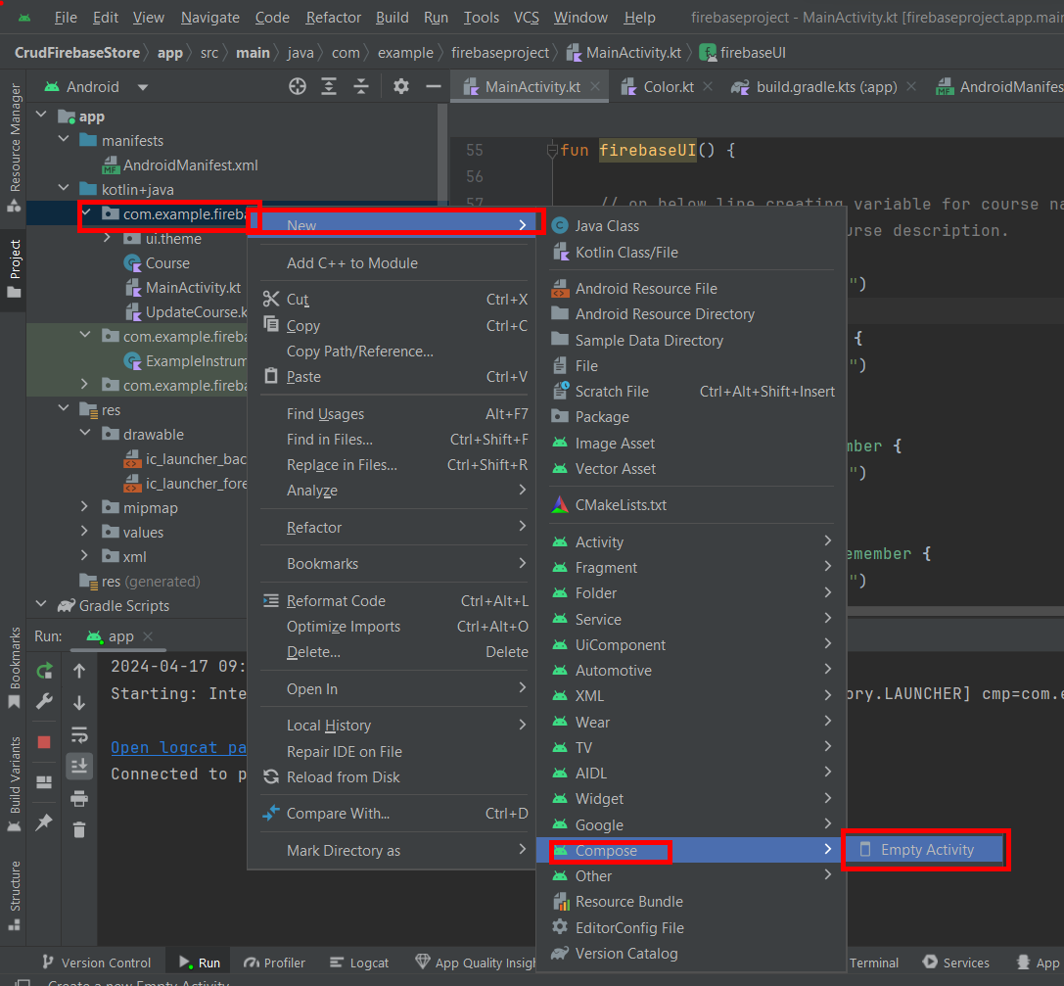
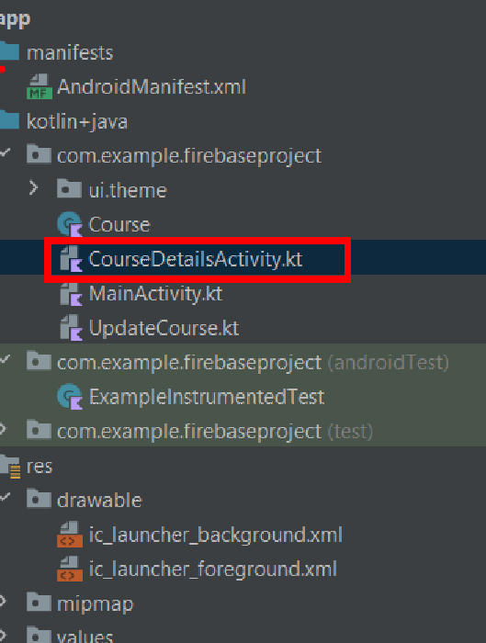

Code tệp CourseDetailsActivity.kt như sau
package com.example.firebaseproject
import android.annotation.SuppressLint
import android.content.Context
import android.content.Intent
import android.os.Bundle
import android.util.Log
import android.widget.Toast
import androidx.activity.ComponentActivity
import androidx.activity.compose.setContent
import androidx.compose.foundation.background
import androidx.compose.foundation.layout.Arrangement
import androidx.compose.foundation.layout.Column
import androidx.compose.foundation.layout.Spacer
import androidx.compose.foundation.layout.fillMaxHeight
import androidx.compose.foundation.layout.fillMaxSize
import androidx.compose.foundation.layout.fillMaxWidth
import androidx.compose.foundation.layout.height
import androidx.compose.foundation.layout.padding
import androidx.compose.foundation.layout.width
import androidx.compose.foundation.lazy.LazyColumn
import androidx.compose.foundation.lazy.itemsIndexed
import androidx.compose.material.ExperimentalMaterialApi
import androidx.compose.material.Card
import androidx.compose.material3.ExperimentalMaterial3Api
import androidx.compose.material3.MaterialTheme
import androidx.compose.material3.Scaffold
import androidx.compose.material3.Surface
import androidx.compose.material3.Text
import androidx.compose.material3.TopAppBar
import androidx.compose.runtime.Composable
import androidx.compose.runtime.mutableStateListOf
import androidx.compose.runtime.snapshots.SnapshotStateList
import androidx.compose.ui.Alignment
import androidx.compose.ui.Modifier
import androidx.compose.ui.graphics.Color
import androidx.compose.ui.platform.LocalContext
import androidx.compose.ui.text.TextStyle
import androidx.compose.ui.text.font.FontWeight
import androidx.compose.ui.text.style.TextAlign
import androidx.compose.ui.unit.dp
import androidx.compose.ui.unit.sp
import com.example.firebaseproject.ui.theme.FirebaseprojectTheme
import com.example.firebaseproject.ui.theme.greenColor
import com.google.firebase.firestore.FirebaseFirestore
class CourseDetailsActivity : ComponentActivity() {
@OptIn(ExperimentalMaterial3Api::class)
@SuppressLint("UnrememberedMutableState")
override fun onCreate(savedInstanceState: Bundle?) {
super.onCreate(savedInstanceState)
setContent {
FirebaseprojectTheme {
// A surface container using the 'background' color from the theme
Surface(
modifier = Modifier.fillMaxSize(),
color = MaterialTheme.colorScheme.background
) {
Scaffold(
// in scaffold we are specifying the top bar.
topBar = {
// inside top bar we are
// specifying background color.
TopAppBar(
// along with that we are specifying
// title for our top bar.
title = {
// in the top bar we are
// specifying tile as a text
Text(
// on below line we are specifying
// text to display in top app bar
text = "GFG",
// on below line we are specifying
// modifier to fill max width
modifier = Modifier.fillMaxWidth(),
// on below line we are specifying
// text alignment
textAlign = TextAlign.Center,
// on below line we are specifying
// color for our text.
color = Color.White
)
})
}) { innerPadding ->
Text(
modifier = Modifier.padding(innerPadding),
text = "Cap nhat du lieu."
)
// on below line creating variable for list of data.
var courseList = mutableStateListOf<Course?>()
// on below line creating variable for freebase database
// and database reference.
var db: FirebaseFirestore = FirebaseFirestore.getInstance()
// on below line getting data from our database
db.collection("Courses").get()
.addOnSuccessListener { queryDocumentSnapshots ->
// after getting the data we are
// calling on success method
// and inside this method we are
// checking if the received query
// snapshot is empty or not.
if (!queryDocumentSnapshots.isEmpty) {
// if the snapshot is not empty we are
// hiding our progress bar and adding
// our data in a list.
// loadingPB.setVisibility(View.GONE)
val list = queryDocumentSnapshots.documents
for (d in list) {
// after getting this list we are passing that list
// to our object class.
val c: Course? = d.toObject(Course::class.java)
c?.courseID = d.id
Log.e("TAG", "Course id is : " + c!!.courseID)
// and we will pass this object class
// inside our arraylist which we have
// created for list view.
courseList.add(c)
}
} else {
// if the snapshot is empty we are
// displaying a toast message.
Toast.makeText(
this@CourseDetailsActivity,
"No data found in Database",
Toast.LENGTH_SHORT
).show()
}
}
// if we don't get any data
// or any error we are displaying
// a toast message that we donot get any data
.addOnFailureListener {
Toast.makeText(
this@CourseDetailsActivity,
"Fail to get the data.",
Toast.LENGTH_SHORT
).show()
}
// on below line we are calling method to display UI
firebaseUI(LocalContext.current, courseList)
// ket thuc
}
}
}
}
}
@OptIn(ExperimentalMaterialApi::class)
@Composable
fun firebaseUI(context: Context, courseList: SnapshotStateList<Course?>) {
// on below line creating a column
// to display our retrieved list.
Column(
// adding modifier for our column
modifier = Modifier
.fillMaxHeight()
.fillMaxWidth()
.background(Color.White),
// on below line adding vertical and
// horizontal alignment for column.
verticalArrangement = Arrangement.Top,
horizontalAlignment = Alignment.CenterHorizontally
) {
// on below line we are calling lazy column
// for displaying listview.
LazyColumn {
// on below line we are setting data
// for each item of our listview.
itemsIndexed(courseList) { index, item ->
// on below line we are creating
// a card for our list view item.
Card(
onClick = {
// on below line opening new activity and passing data.
val i = Intent(context, UpdateCourse::class.java)
i.putExtra("courseName", item?.courseName)
i.putExtra("courseDuration", item?.courseDuration)
i.putExtra("courseDescription", item?.courseDescription)
i.putExtra("courseID", item?.courseID)
// inside on click we are opening
// new activity to update course details.
context.startActivity(i)
},
// on below line we are adding
// padding from our all sides.
modifier = Modifier.padding(8.dp),
// on below line we are adding
// elevation for the card.
elevation = 6.dp
) {
// on below line we are creating
// a row for our list view item.
Column(
// for our row we are adding modifier
// to set padding from all sides.
modifier = Modifier
.padding(8.dp)
.fillMaxWidth()
) {
// on below line inside row we are adding spacer
Spacer(modifier = Modifier.width(5.dp))
// on below line we are displaying course name.
courseList[index]?.courseName?.let {
Text(
// inside the text on below line we are
// setting text as the language name
// from our modal class.
text = it,
// on below line we are adding padding
// for our text from all sides.
modifier = Modifier.padding(4.dp),
// on below line we are adding color for our text
color = greenColor,
textAlign = TextAlign.Center,
style = TextStyle(
fontSize = 20.sp, fontWeight = FontWeight.Bold
)
)
}
// adding spacer on below line.
Spacer(modifier = Modifier.height(5.dp))
// on below line displaying text for course duration
courseList[index]?.courseDuration?.let {
Text(
// inside the text on below line we are
// setting text as the language name
// from our modal class.
text = it,
// on below line we are adding padding
// for our text from all sides.
modifier = Modifier.padding(4.dp),
// on below line we are adding color for our text
color = Color.Black,
textAlign = TextAlign.Center,
style = TextStyle(
fontSize = 15.sp
)
)
}
// adding spacer on below line.
Spacer(modifier = Modifier.width(5.dp))
// on below line displaying text
// for course description
courseList[index]?.courseDescription?.let {
Text(
// inside the text on below line we are
// setting text as the language name
// from our modal class.
text = it,
// on below line we are adding padding
// for our text from all sides.
modifier = Modifier.padding(4.dp),
// on below line we are
// adding color for our text
color = Color.Black,
textAlign = TextAlign.Center,
style = TextStyle(fontSize = 15.sp)
)
}
}
}
}
}
}
}
}

Bước 7. Tạo Compose UpdateCourse như sau

package com.example.firebaseproject
import android.os.Bundle
import androidx.activity.ComponentActivity
import androidx.activity.compose.setContent
import androidx.compose.foundation.layout.fillMaxSize
import androidx.compose.material3.MaterialTheme
import androidx.compose.material3.Surface
import androidx.compose.material3.Text
import androidx.compose.runtime.Composable
import androidx.compose.ui.Modifier
import com.example.firebaseproject.ui.theme.FirebaseprojectTheme
import android.content.Context
import android.content.Intent
import android.text.TextUtils
import android.widget.Toast
import androidx.compose.foundation.background
import androidx.compose.foundation.layout.*
import androidx.compose.material.*
import androidx.compose.runtime.*
import androidx.compose.ui.Alignment
import androidx.compose.ui.graphics.Color
import androidx.compose.ui.platform.LocalContext
import androidx.compose.ui.text.TextStyle
import androidx.compose.ui.text.style.TextAlign
import androidx.compose.ui.unit.dp
import androidx.compose.ui.unit.sp
import com.example.firebaseproject.ui.theme.greenColor
import com.google.firebase.firestore.FirebaseFirestore
class UpdateCourse : ComponentActivity() {
override fun onCreate(savedInstanceState: Bundle?) {
super.onCreate(savedInstanceState)
setContent {
FirebaseprojectTheme {
// A surface container using the 'background' color from the theme
Surface(
modifier = Modifier.fillMaxSize(),
color = MaterialTheme.colorScheme.background
) {
Scaffold(
// in scaffold we are specifying the top bar.
topBar = {
// inside top bar we are specifying
// background color.
TopAppBar(backgroundColor = greenColor,
// along with that we are specifying
// title for our top bar.
title = {
// in the top bar we are specifying
// title as a text
Text(
// on below line we are specifying
// text to display in top app bar
text = "GFG",
// on below line we are specifying
// modifier to fill max width
modifier = Modifier.fillMaxWidth(),
// on below line we are specifying
// text alignment
textAlign = TextAlign.Center,
// on below line we are specifying
// color for our text.
color = Color.White
)
})
}) { innerPadding ->
Text(
modifier = Modifier.padding(innerPadding),
text = "Cap nhat du lieu."
)
// on below line getting data from our database
// on below line we are calling method to display UI
firebaseUI(
LocalContext.current,
intent.getStringExtra("courseName"),
intent.getStringExtra("courseDuration"),
intent.getStringExtra("courseDescription"),
intent.getStringExtra("courseID")
)
}
}
}
}
}
// cap nhat
@Composable
fun firebaseUI(
context: Context,
name: String?,
duration: String?,
description: String?,
courseID: String?
) {
// on below line creating variable for course name,
// course duration and course description.
val courseName = remember {
mutableStateOf(name)
}
val courseDuration = remember {
mutableStateOf(duration)
}
val courseDescription = remember {
mutableStateOf(description)
}
// on below line creating a column
Column(
// adding modifier for our column
modifier = Modifier
.fillMaxHeight()
.fillMaxWidth()
.background(Color.White),
// on below line adding vertical and
// horizontal alignment for column.
verticalArrangement = Arrangement.Center,
horizontalAlignment = Alignment.CenterHorizontally
) {
TextField(
// on below line we are specifying
// value for our course name text field.
value = courseName.value.toString(),
// on below line we are adding on
// value change for text field.
onValueChange = { courseName.value = it },
// on below line we are adding place holder
// as text as "Enter your course name"
placeholder = { Text(text = "Enter your course name") },
// on below line we are adding modifier to it
// and adding padding to it and filling max width
modifier = Modifier
.padding(16.dp)
.fillMaxWidth(),
// on below line we are adding text style
// specifying color and font size to it.
textStyle = TextStyle(color = Color.Black, fontSize = 15.sp),
// on below line we are adding
// single line to it.
singleLine = true,
)
Spacer(modifier = Modifier.height(10.dp))
TextField(
// on below line we are specifying
// value for our course duration text field.
value = courseDuration.value.toString(),
// on below line we are adding on
// value change for text field.
onValueChange = { courseDuration.value = it },
// on below line we are adding place holder
// as text as "Enter your course duration"
placeholder = { Text(text = "Enter your course duration") },
// on below line we are adding modifier to it
// and adding padding to it and filling max width
modifier = Modifier
.padding(16.dp)
.fillMaxWidth(),
// on below line we are adding text style
// specifying color and font size to it.
textStyle = TextStyle(color = Color.Black, fontSize = 15.sp),
// on below line we are adding
// single line to it.
singleLine = true,
)
Spacer(modifier = Modifier.height(10.dp))
TextField(
// on below line we are specifying
// value for our course description text field.
value = courseDescription.value.toString(),
// on below line we are adding on
// value change for text field.
onValueChange = { courseDescription.value = it },
// on below line we are adding place holder
// as text as "Enter your course description"
placeholder = { Text(text = "Enter your course description") },
// on below line we are adding modifier to it
// and adding padding to it and filling max width
modifier = Modifier
.padding(16.dp)
.fillMaxWidth(),
// on below line we are adding text style
// specifying color and font size to it.
textStyle = TextStyle(color = Color.Black, fontSize = 15.sp),
// on below line we are adding
// single line to it.
singleLine = true,
)
Spacer(modifier = Modifier.height(10.dp))
// on below line creating button to add data
// to firebase firestore database.
Button(
onClick = {
// on below line we are validating user input parameters.
if (TextUtils.isEmpty(courseName.value.toString())) {
Toast.makeText(context, "Please enter course name", Toast.LENGTH_SHORT)
.show()
} else if (TextUtils.isEmpty(courseDuration.value.toString())) {
Toast.makeText(
context,
"Please enter course Duration",
Toast.LENGTH_SHORT
)
.show()
} else if (TextUtils.isEmpty(courseDescription.value.toString())) {
Toast.makeText(
context,
"Please enter course description",
Toast.LENGTH_SHORT
)
.show()
} else {
// on below line adding data to
// firebase firestore database.
updateDataToFirebase(
courseID,
courseName.value,
courseDuration.value,
courseDescription.value,
context
)
}
},
// on below line we are
// adding modifier to our button.
modifier = Modifier
.fillMaxWidth()
.padding(16.dp)
) {
// on below line we are adding text for our button
Text(text = "Update Data", modifier = Modifier.padding(8.dp))
}
Spacer(modifier = Modifier.height(10.dp))
}
}
private fun updateDataToFirebase(
courseID: String?,
name: String?,
duration: String?,
description: String?,
context: Context
) {
// inside this method we are passing our updated values
// inside our object class and later on we
// will pass our whole object tofirebase Firestore.
val updatedCourse = Course(courseID, name, duration, description)
// getting our instance from Firebase Firestore.
val db = FirebaseFirestore.getInstance();
db.collection("Courses").document(courseID.toString()).set(updatedCourse)
.addOnSuccessListener {
// on below line displaying toast message and opening
// new activity to view courses.
Toast.makeText(context, "Course Updated successfully..", Toast.LENGTH_SHORT).show()
context.startActivity(Intent(context, CourseDetailsActivity::class.java))
// finish()
}.addOnFailureListener {
Toast.makeText(context, "Fail to update course : " + it.message, Toast.LENGTH_SHORT)
.show()
}
}
}
chạy demo
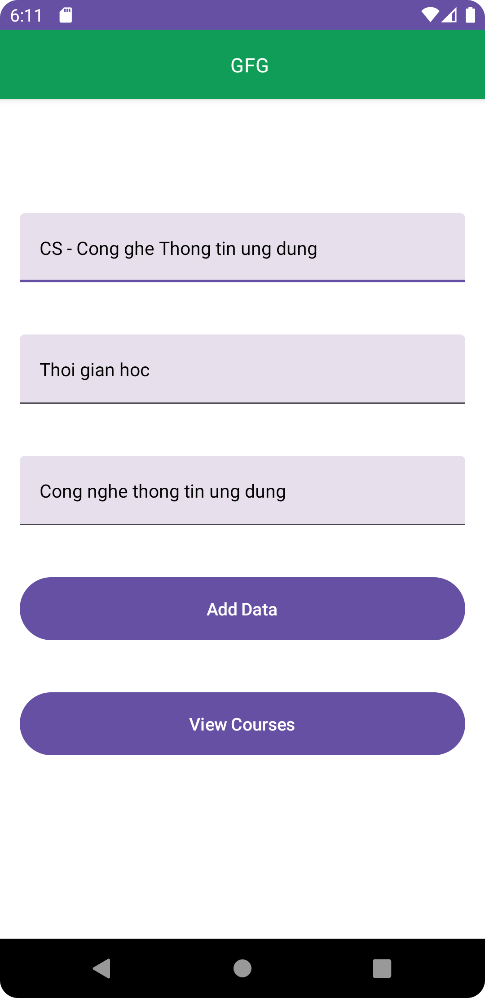
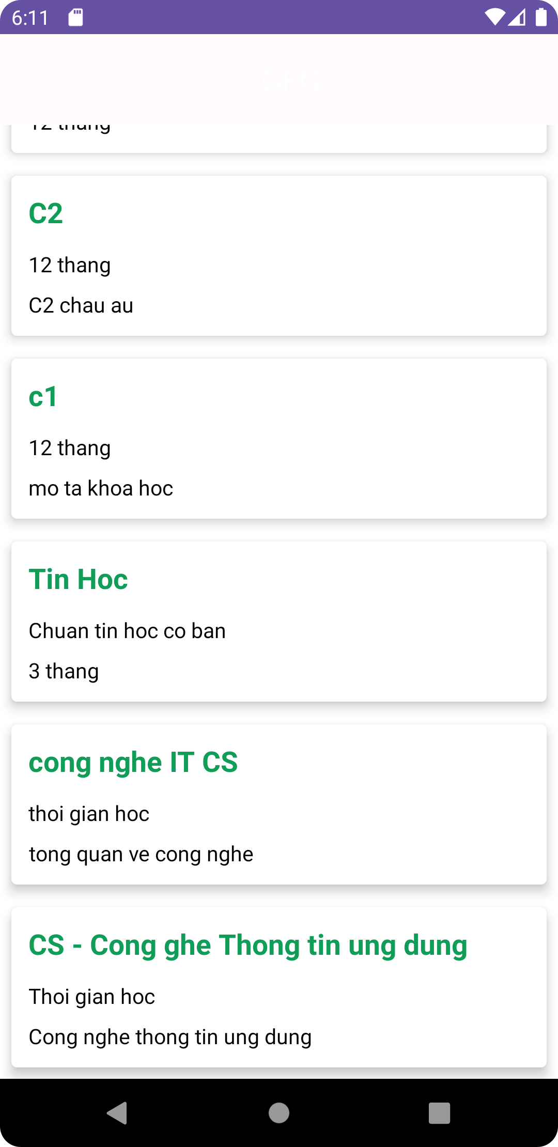

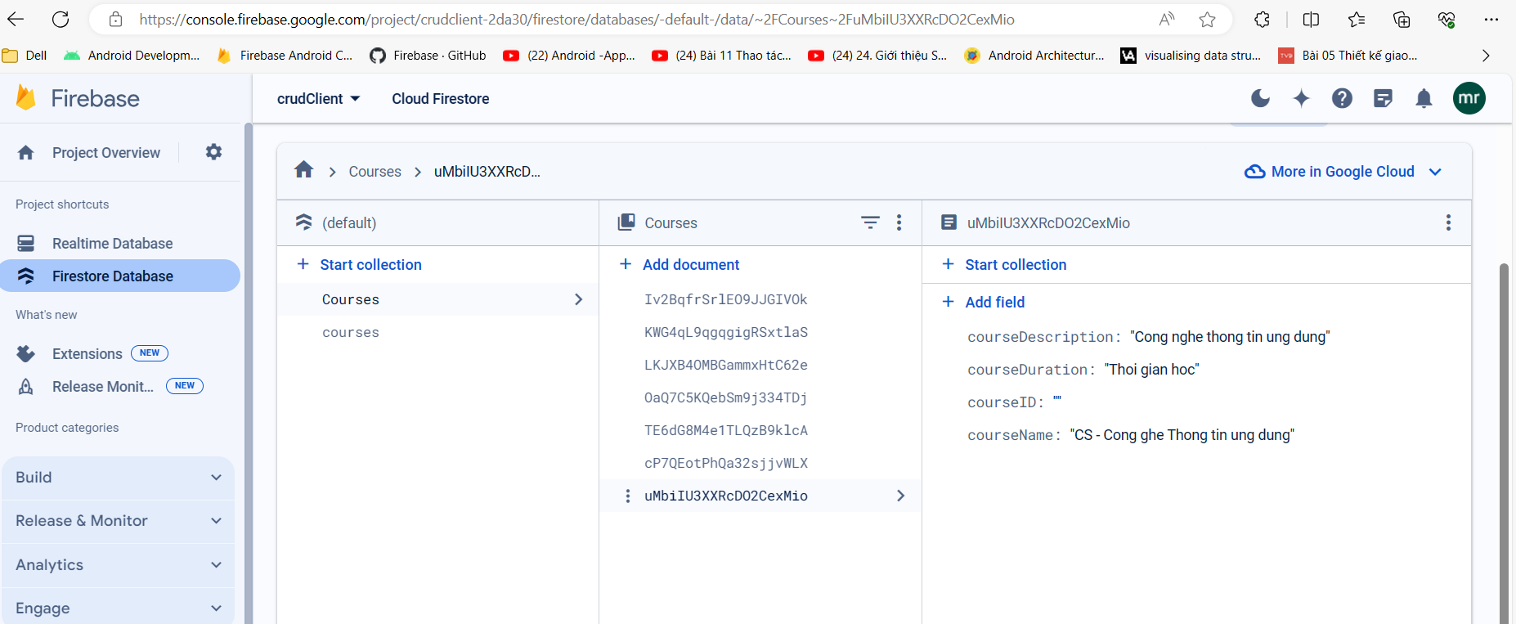

Demo cap nhat du lieu

